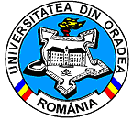 | 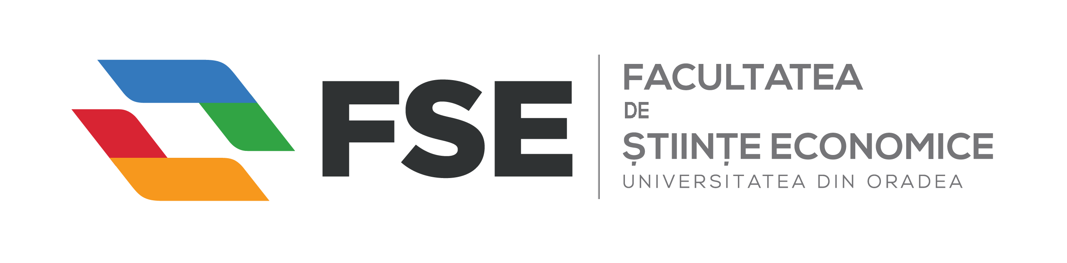
Str. Universităţii, nr. 1, cod poştal 410087, Oradea, jud. Bihor, România
Telefon: Secretariat: 0259-408276, 0259-408407; Decanat: 0259-408109; Fax: 0259-408409
Web: http://steconomice.uoradea.ro; E-mail: steconomice@uoradea.ro

INVITATION

DOCTORAL SYMPOSIUM IN ECONOMIC SCIENCES
"Romania and the challenges of economic crisis. The response of young researchers "
Fifth Edition
Oradea, 23rd of November 2016

The event will take place starting at 16:00, at the Faculty of Economics, University of Oradea and is part of the events organized on the occasion of the "The Day of the Economist and Economics Teacher". There are expected mainly PhD students and recent doctors (title obtained in the last 5 years) from local and foreign universities, in economics and related sciences area.

The objectives of the event:
- Communication by the PhD in Economics and related/complementary areas of the most valuable results from their own research;
- Awareness and the assumption by young scientists of the role and their responsibilities on theoretical research, but also in terms of practical solutions to contemporary social and economic problems;
- Forum to stimulate communication between PhD students with an interest similar and/or related items in research directions.

The Chair of the Doctoral Symposium:
Ph.D. Professor Alina BĂDULESCU – Dean of the Faculty of Economic Studies, University of Oradea

Scientific Council:
- Ph.D. Professor Mihai BERINDE – University of Oradea, Faculty of Economic Sciences and Doctoral School in Economic Sciences
- Ph.D. Professor habil. Daniel BĂDULESCU – University of Oradea, Faculty of Economic Sciences, Department of Economics and Doctoral School in Economic Sciences, Director of the Research Centre for Competitiveness and Sustainable Development
- Ph.D. Professor habil. Florica ȘTEFĂNESCU – University of Oradea, Faculty of Social-Humanistic Sciences and Doctoral School in Economic Sciences
- Ph.D. Professor Gheorghe OLAH – University of Oradea, Doctoral School in Economic Sciences
- Ph.D. Professor Claudia-Diana SABĂU-POPA – Vice-dean, University of Oradea, Faculty of Economic Sciences
- Ph.D. Professor Olimpia BAN – University of Oradea, Faculty of Economic Sciences, Department of Economics
- Ph.D. Senior Lecturer Adriana GIURGIU – Vice-dean, University of Oradea, Faculty of Economic Sciences
- Ph.D. Senior Lecturer Dorin BÂC – University of Oradea, Faculty of Economic Sciences, Department of Economics
- Ph.D. Senior Lecturer Ioana MEȘTER – University of Oradea, Faculty of Economic Sciences, Department of Economics
- Ph.D. Senior Lecturer Adrian FLOREA – University of Oradea, Faculty of Economic Sciences, Department of Economics
- Ph.D. Lecturer. Mariana SEHLEANU – University of Oradea, Faculty of Economic Sciences, Department of Economics
- Ph.D. Lecturer Diana PERȚICAȘ – University of Oradea, Faculty of Economic Sciences, Department of Economics

Organization Committee:
- Ph.D. Ramona Simuț
- Ph.D. Roxana Hatos
- Ph.D. student Diana Sava
- Ph.D. student Felix Popescu
- Ph.D. student Otilia Cadar

The sections and the program will be determined later, depending on the number and the topics of the received papers.

Contact:
Doctoral Symposium: sesiunedrdec@gmail.com
Conference Chair: Ph.D. Professor Alina Bădulescu: abadulescu@uoradea.ro

Terms and deadlines:

The papers will be written in English, JIS format, as the model (see document: Model Paper Doctoral Symposium Oradea) and will have exactly 4 pages. Power point presentations of the paper will be done in Romanian or English, within 10-15 minutes/paper. Accepted papers will be published, after the review, in a volume with an ISBN / ISSN code, published by the University of Oradea.

The full paper (4 pages), accompanied by a file containing only the title of the paper in Romanian and English and authors' names will be sent by email to sesiunedrdec@gmail.com until 4th of November, 2016.
There will be accepted for publication only the papers submitted strictly within the deadline, that fully comply the requirements of formatting, in Economics and related area (Economic / Social Sciences / Law) and meet the scientific requirements of such events.

All papers will be reviewed by members of the Scientific Committee. The papers which do not fully comply to the formatting rules will be automatically rejected, before the reviewing process.

The notification of acceptance / rejection of paper will be sent by email to the PhD. student until 19th of November, 2016. Publication of the papers in the Conference Proceedings will be done after the session, by the end of 2016.

The Ph.D. students may submit a maximum of two papers, either as sole author or with their PhD. coordinator, or with another PhD student(s). There are not accepted papers with more than 4 co-authors. There will be also admitted papers authored by recent Ph.D. graduates (who obtained the PhD title in the last 5 years) and from post-doctoral students.

Publishing opportunities:
The conference paper (4 pages) will be published free of charges in the conference volume. Additionally, all authors could submit extended versions of their papers, with different title (between 8 and 10 pages, according to the journal’s requirements), to be published in ”Oradea Journal of Business and Economics - OJBE” – Issue 3 (March 2016) http://ojbe.steconomiceuoradea.ro/ and the ”Annals of the University of Oradea, Economic Sciences Series/Analele Universității din Oradea, seria Științe Economice”, Volume II (December 2015) – http://anale.steconomiceuoradea.ro/en/ – journals indexed in multiple international databases. The extended papers will have to meet the journal’s criteria and they will pass through standard reviewing process. The extended papers have to be sent until 1st of December 2016 (for the ”Annals”), respectively 1st of February 2017 (for OJBE).

Fees and payment:
There is no fee for participation in the conference and publication in the Conference Proceedings. Eventual travel expenses, accommodation and meals will be borne by the participants.
For publication of the extended version of the paper in Oradea Journal of Business and Economics - OJBE there is no fee. For publication in the Annals of the University of Oradea, Economic Sciences Series/ Analele Universității din Oradea, seria Științe Economice, the fee is 150 lei (approx. 35 EURO).

